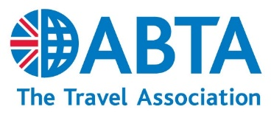
Mid-term Election to the Council or Regions 2021
CURRICULEM VITAE
Please enter your information, then print out, sign a copy and sent it to us with your proposal form and photograph.
Please use additional sheets if required.
Full name:
Name and address of company or firm of which the candidate is the authorised representative:
Tel: |  |  |  | Mobile*: |  |  |  | Email:
Position held in company:
Residential address*:
Residential tel*: |  |  |  |  |  |  | DOB*:

Election statement (maximum 200 words):

Travel industry experience and ABTA involvement: | Period (e.g. 2000 – 2004)

Experience outside the travel industry: | Period (e.g. 2000 – 2004)

Signature: |  | Date:
*for secretariat use only

